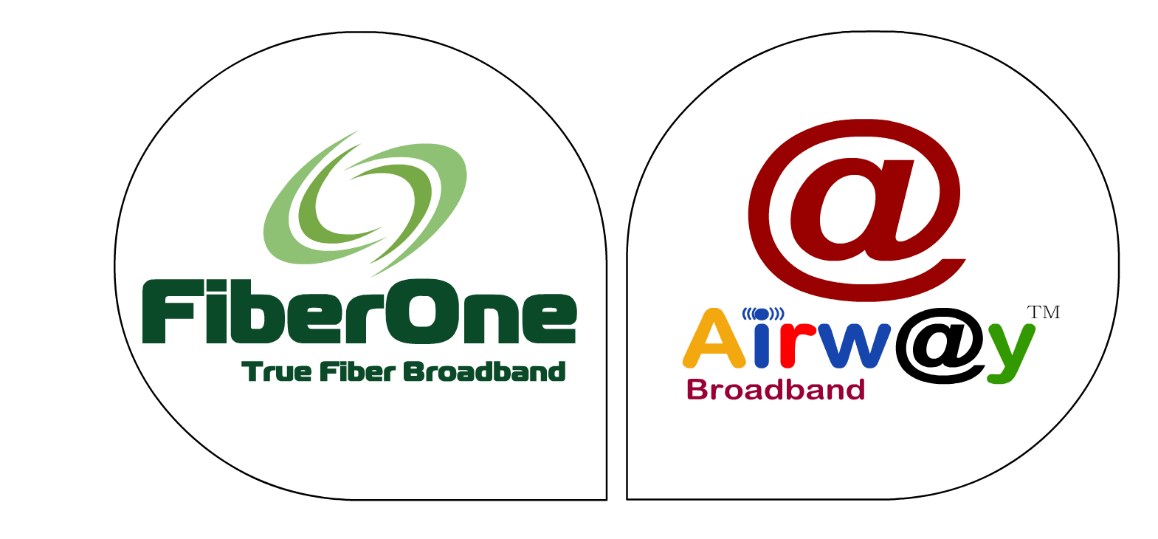
GST DATA UPDATE FORM
(Pc Care Airway Infratel Private Limited)
CIN: U64204MP2017PTC043127

Subscriber / Client Name

Subscriber Type Home SME Institutional

Subscribed Service Airway Broadband FiberOne Broadband Internet Lease Line
Local Loop Dark Fiber Tower Space
Other Please Specify________________________________________________

Constitution of company /Business (Please Tick One)

    - Private Limited Public Limited LLP (Limited Liability Partnership)

    - Partnership Firm Proprietor Ship Firm Government Department

Hindu Undivided Family
OFFICIAL DETAILS

Name of Contact Person

1
9
+

Contact Person Mobile no

Contact Person Mail ID

Permanent Account Number (PAN)

Aadhar Card No

GSTIN NO

GST Registered Address

Y
Y
Y
Y
M
D
D
M
GSTIN Issuing Date

It is hereby declared that the information and particulars furnished above are true and correct to the best of my/our knowledge and belief and nothing has been concealed.

Name:-
Designation:-
Mobile no:-
Signature

Please Note: - After filling this from kindly mail to us scan copy on account@pccareonline.in

